**User Documentation: the use of graphical interface**

When you import this project, you must install this package: psutils, socket, threading, pyqt5.QTWidgets and sys.

You can use the function “python package” in PyCharm:

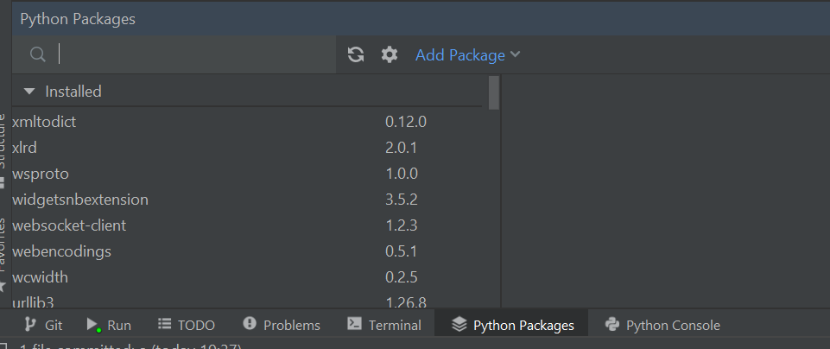

You must run “serv.py”. This information must appear:



And finally run “int.py”, this page must opened:

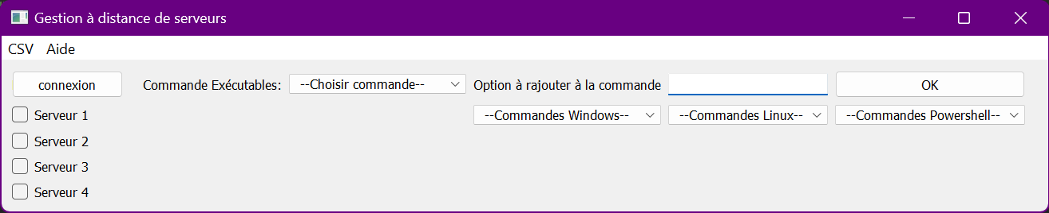

The bouton “Connexion” allows a connection with a server.

The different functionality

Menu bar

CSV

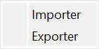 Allow CSV importation (machines login information) and exportation (configurations).

Aide

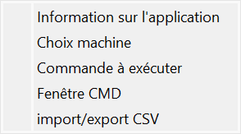 This section has information about different page module in French.

Main page

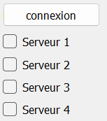You can choose the connection to a sever.



This part is the section for the command choice.

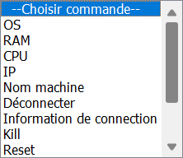In the main choice, you have commune command and choice for specific commands (windows, Linux, PowerShell, mac os).

Some command requires additional information like the ping command.